PTO App — MVP Product Specification
Nov 4, 2026 · @Miguel Ángel Betancur
This is the product spec for the 5-employee pilot. It's for review before we hand it to an AI coding agent. It covers product behavior only. Everything in it comes from the PTO Guide (April 2026), the feasibility report and the decisions already made. Anything not yet confirmed is labeled as an assumption or an open question.

1. MVP scope & exclusions
The MVP is the pilot: a standalone web app where 5 employees with made-up data request, approve and track every leave type. The internal balance is calculated next to the legal (EOR) balance.
In scope
- Balances per employee: the legal balance (entered by the admin, shown with a "last reconciled" date), the internal 30-day balance, and the top-up remaining
- Requests for the 7 leave types: Vacation (legal + top-up), Maternity, Paternity, Sick, Bereavement, Marriage/Honeymoon, Family Emergency. Plus Year-end shutdown days
- Automatic split of each vacation request into a legal portion and a top-up portion, with legal used first
- Generated "what to file in Deel" instructions for the legal portion of each request
- Manager approve / deny; admin confirmation and reconciliation against Deel
- Request validation: weekend splitting (blocked), team overlap, blackout periods, advance notice
- Cancel / modify an approved request (cancel and resubmit)
- Team calendar for managers and admin
- Admin configuration: employees, entities (VER+ / VERE), teams, countries, holidays, blackout periods, opening balances, and CEO-approved exceptions (year-end shutdown activation, blackout overrides, extensions, unpaid leave) recorded on the CEO's behalf. Notifications are in-app only: pending queues and status changes
- Countries in the pilot: Colombia, Uruguay, Costa Rica, Brazil, Panama (United States added after the pilot)
Explicitly excluded from the MVP
Excluded | Why / when
Deel API sync | Phase 3; the MVP reconciles manually
Slack, email notifications, United States rules | No external connections in the MVP; Slack likely after the pilot; US state rules after the pilot
Migration of real balances and history | Only if the pilot succeeds
CEO role | The admin records CEO-approved exceptions instead
Storing medical certificates or other leave documents | Health data stays in the EOR; the app keeps dates and type only
Filing requests in Deel on the employee's behalf | The employee still files the legal portion in Deel
Handover email, out-of-office reply, shared calendar entry | The guide requires these, but they stay manual
Brazil Abono Pecuniário (cash conversion) | Still handled in Deel
Day Off decommissioning | Phase 2 (rollout)

2. Users & roles
There are three roles, and one person can hold more than one. For example, a manager is also an employee.
Capability | Employee | Direct Manager | Dir. Staff & Ops (admin)
See own balances and request history | Yes | Yes | Yes
Create, cancel or modify own requests | Yes | Yes | Yes
See Deel filing instructions for own requests | Yes | Yes | Yes
Approve / deny requests | No | Direct reports only | Assumption: all
See team calendar | Assumption: own team | Own team(s) | All
Confirm requests and mark Deel reconciliation | No | No | Yes
Enter or adjust legal balances from Deel | No | No | Yes
Configure employees, teams, entities, countries, holidays, blackouts | No | No | Yes
The guide's flow is: employee submits, manager approves or denies, Dir. Staff & Ops is notified and confirms.

3. Primary user journey
An employee requests vacation, the manager approves it, and the admin reconciles it with Deel. This journey covers the core value of the app: one request, two ledgers, one true balance.
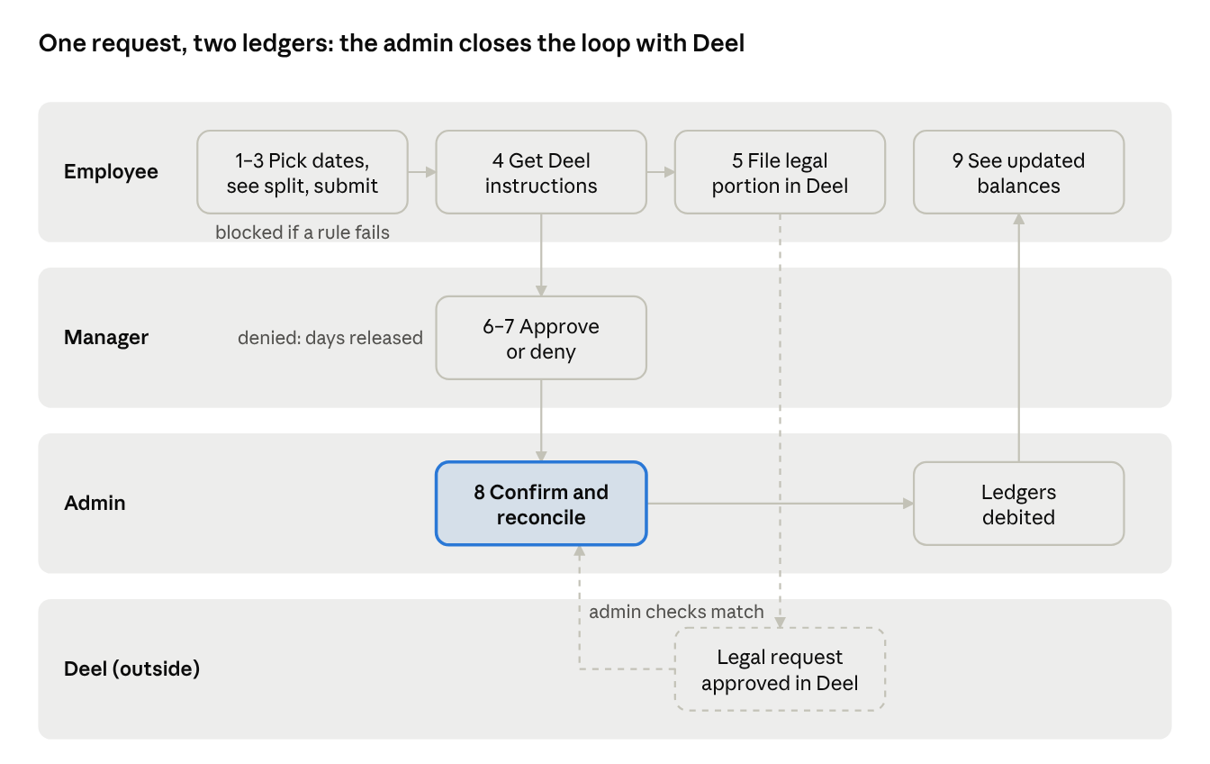
primary journey · vacation request across 4 lanes
The numbers match the steps in section 4. Dashed lines are actions outside the app. Ledgers debited on admin confirmation is an assumption (section 7).

4. Expected system behavior per step
The journey is "an employee requests vacation that spans the legal and top-up portions." Other leave types follow the same steps; their differences are noted in step 2.
# | Actor | Action | System behavior | Visible result
1 | Employee | Opens the app | Shows the legal balance (with its last-reconciled date), the internal balance out of 30, the top-up remaining, and the policy-year dates (hire anniversary) | Balance summary
2 | Employee | Picks a leave type and a date range | Calculates the request live: working days against the legal ledger (country holidays and working week applied), and the internal days per the conversion rule. Legal is used first; the rest goes to the top-up. Maternity/Paternity: 126 / 60 calendar days, legal portion + top-up. Sick and Bereavement: the legal ledger only. Marriage and Family Emergency: their own 5-day balances | Breakdown: legal X working days + top-up Y days; balances after the request
3 | Employee | Submits | Runs the validations (section 5). A blocking rule stops the submit with a reason. A warning lets the submit go through, and the manager sees it | Request status Pending, or an error message
4 | System | After submit | Generates the Deel filing instructions: leave type, start and end dates, number of working days, and suggested note text | "File this in Deel" card on the request
5 | Employee | Files the legal portion in Deel (outside the app) | Nothing; the app does not connect to Deel | —
6 | Manager | Reviews pending requests | Shows the breakdown, warnings, team overlaps, and the requester's days used this year (the priority rule) | Pending queue
7 | Manager | Approves or denies (a reason on deny) | Records the decision and who made it. Denied: the requested days are released | Status Approved by manager, or Denied
8 | Admin | Confirms and reconciles with Deel | The admin marks the request as matching Deel, or flags a mismatch. The admin may also update the legal balance from Deel. The ledgers debit only when the admin confirms (assumption) | Status Confirmed; last-reconciled date updates
9 | Employee | Sees the outcome | Balances update. The request appears on the team calendar | Updated balance summary
10 | Employee | Cancels or modifies (optional) | Cancel releases the days and creates new Deel instructions (cancel in Deel). Modify = cancel + new request, as the guide requires | Status Cancelled, plus the new request if any

5. UX states & edge cases
Request statuses: Draft → Pending → Approved by manager → Confirmed (reconciled) · Denied · Cancelled. Plus a "Deel mismatch" flag the admin can set on any approved request.
Screen states to design
Screen | States
Balance summary | Normal · legal balance never entered (empty state, admin action needed) · legal balance stale (old last-reconciled date) · legal balance negative (on credit) · top-up exhausted · Brazil/Panama (no top-up row)
New request | Live breakdown · blocking error with reason · warning shown, submit allowed · insufficient balance
Request detail | Each status above · Deel instructions shown · mismatch flagged
Manager queue | Empty · pending items · item with overlap or priority conflict
Team calendar | Empty · overlapping requests highlighted
Validation rules and edge cases
Case | Source | Expected behavior
Leave splits around a weekend (e.g. Fri off, then Mon off) | Confirmed decision | Block, with a message to submit one continuous range
Request overlaps an approved request from the same team | PTO Guide | Block (assumption: block, not warn)
Two pending requests from the same team overlap | PTO Guide | Allowed; the manager sees both, and the one with fewer days used this year is marked as having priority
Request falls in a blackout period | PTO Guide | Block, unless the admin records a CEO-approved exception for that request
Vacation submitted less than 1 week ahead (30 days for Maternity/Paternity) | PTO Guide | Warning only (assumption; the guide says "when possible")
Retroactive request (dates in the past) | PTO Guide | Allowed with a required justification note (assumption)
Legal balance not yet accrued | PTO Guide ("on credit") | Allowed, and the legal balance goes negative; the cap is unresolved
Top-up requested before legal is used up | Confirmed (legal first) | Not possible: the system always fills legal first
Not enough total balance | Derived | Block, showing how many days are available
Holiday inside the range (CO, UY, CR) | PTO Guide + confirmed rule | Not counted as a legal working day, but still charged as a calendar day internally
Request crosses the hire anniversary | Confirmed (anniversary year) | Unresolved: split across two policy years, or charge the year it starts in
Marriage leave | PTO Guide | 5 days; may start up to 1 week before the wedding and be used up to 1 year after; no carryover
Family Emergency | PTO Guide | 5 days per year; no carryover
Year-end shutdown | PTO Guide | Only if activated for that year (the admin records it on the CEO's behalf); fixed dates; cannot be moved, carried over or cashed out
Sick / Bereavement | Confirmed | Dates and type only; reminder to submit the certificate in Deel

6. Acceptance criteria
Each one can be checked in the pilot with scripted data. Criteria marked ⚠ depend on an unresolved decision (section 7) and must be rechecked once it's decided.
Balances & calculation
- ☐ AC-1 Given a Colombian employee with 15 legal working days and 30 internal days, when they request Mon 1 Feb – Fri 19 Feb 2027, then the breakdown shows 15 legal working days and 21 calendar days charged internally (1 Feb – 21 Feb, including the trailing weekend), leaving 9 days of top-up. ⚠ (the exact weekend-charging rule is an assumption)
- ☐ AC-1b Given a Colombian employee, when they request three separate Mon–Fri weeks, then each week is charged 7 calendar days internally (21 in total), the same as one continuous block. ⚠
- ☐ AC-2 Given a range that includes a Colombian holiday (e.g. 22 Mar 2027), when the breakdown is calculated, then the holiday is not counted as a legal working day.
- ☐ AC-3 Given any vacation request, when legal days remain, then no top-up days are used until the legal balance (including allowed credit) is used up.
- ☐ AC-4 Given a Brazilian or Panamanian employee, when they view balances, then there's no top-up row and vacation counts in calendar days only.
- ☐ AC-5 Given the admin updated the legal balance on a date, when any user views it, then that date is shown as "last reconciled".
Request flow
- ☐ AC-6 Given a submitted vacation request, when it's saved, then the request shows Deel filing instructions with leave type, start date, end date and working days.
- ☐ AC-7 Given a pending request, when the direct manager approves it, then its status becomes "Approved by manager" and the admin sees it in the queue to confirm.
- ☐ AC-8 Given a pending request, when the manager denies it without a reason, then the deny is not saved. (Assumption: a reason is required.)
- ☐ AC-9 Given a manager, when they open the queue, then they see only requests from their direct reports.
- ☐ AC-10 Given an approved request, when the employee cancels it, then the days return to their balances and the request shows a reminder to cancel it in Deel.
Validation
- ☐ AC-11 Given an approved request ending on a Friday, when the same employee requests the following Monday as separate leave, then the submit is blocked with a message to use one continuous range. ⚠
- ☐ AC-12 Given an approved request from a teammate (same admin-defined team), when an employee requests overlapping dates, then the submit is blocked.
- ☐ AC-13 Given two overlapping pending requests from the same team, when the manager views them, then the one from the employee with fewer vacation days used this year is marked as having priority.
- ☐ AC-14 Given an active blackout period, when an employee it applies to requests dates inside it, then the submit is blocked with the blackout's name and dates.
- ☐ AC-15 Given a vacation request starting less than 7 days out, when it's submitted, then it's accepted with a visible "late request" warning for the manager.
Privacy & roles
- ☐ AC-16 Given a Sick leave request, when it's created, then the app has no field to upload a document, and it shows a reminder to submit the certificate in Deel.
- ☐ AC-17 Given an employee (not manager, not admin), when they try to open another person's request or balances, then access is denied.

7. Decisions, assumptions & open questions

Confirmed decisions
Topic | Decision | Source
Internal policy | 30 calendar days of vacation; 126 maternity; 60 paternity; 5 marriage; 5 family emergency per year; up to 5 year-end days | PTO Guide
Order of use | Legal (EOR) first, then the top-up | PTO Guide
Top-up rule | 30 calendar days total; legal portion used first. Weekends inside or adjacent to a leave are always charged, even when weeks are requested separately | Interview
Policy year / grant | Hire anniversary; all 30 days granted upfront | Interview
EOR relationship | Plan in the app, file in the EOR; the admin reconciles | Interview
Roles | Employee, Direct Manager, Dir. Staff & Ops (admin) | Interview
Entities | VER+ and VERE, same policy | Interview
Countries | CO, UY, CR, BR, PA in the pilot; US after the pilot | Interview
Leave types in the MVP | All 7, plus year-end shutdown | Interview
Weekend splitting | Blocked | Interview
Teams | Admin-defined | Interview
Day Off | Replaced (after the pilot) | Interview
Pilot | 5 employees, made-up data, standalone web app | Interview
CEO-only actions / sick data | The admin records CEO-approved exceptions (year-end activation, blackout overrides, extensions, unpaid leave). Sick leave: dates and type only, no certificates. Notifications: in-app only; no external connections (Slack likely later) | Interview

Assumptions (confirm or correct)
- The ledgers are debited when the admin confirms, not when the manager approves.
- A team overlap with an approved request blocks the request; the advance-notice rule only warns.
- A manager has to give a reason to deny.
- The admin can approve any request, not only their direct reports'.
- Employees can see their own team's calendar.
- Retroactive requests are allowed with a required justification.
- Blackout periods apply to the employees the admin assigns them to (the guide targets the Leadership Team).

Unresolved — blocking hand-off
- ☐ Conversion rule: resolved: 30 calendar days total, legal first, with weekends always charged. Still to confirm: (a) the precise rule assumed here: charge every calendar day from the first day off to the day before the next working day, so a leave ending Friday charges Sat–Sun and a Mon–Fri week costs 7; (b) with weekends charged, is the weekend-split block (AC-11) still needed, or redundant?
- ☐ CEO-only actions (activating the year-end shutdown, blackout overrides, extensions, unpaid leave): resolved: the admin records them on the CEO's behalf.
- ☐ Notifications: resolved: in-app only; Slack likely after the pilot.
- ☐ United States in the pilot: resolved: no, added after the pilot.

Unresolved — can be decided during the pilot
- ☐ Cap on negative legal balance (credit)
- ☐ A request that crosses the hire anniversary: split it, or charge the starting year?
- ☐ Costa Rica: is Saturday a legal working day?
- ☐ Legal Maternity/Paternity days per country
- ☐ Uruguay working-week pattern
- ☐ Carryover limits per country for the top-up

